|  |
| --- |
| **Linear Probing without Replacement** |

**Linear probing** is a scheme in computer programming for resolving collisions in hash tables, data structures for maintaining a collection of key–value pairs and looking up the value associated with a given key.

When some data is to be stored in hash table, and if the slot is already occupied by the key then another empty location is searched for a new record. If a location is already occupied then it search for the empty location.

When collision occurs, scan down the array one cell at a time looking for an empty cell.

hi(X) = [ (Hash(X) + i) mod TableSize ] (i = 0, 1, 2, …)

Compute hash value and increment it until a free cell is found

🡪**Linear Probing without replacement policy: 28, 55, 71, 67, 11, 10, 90 and 44.**

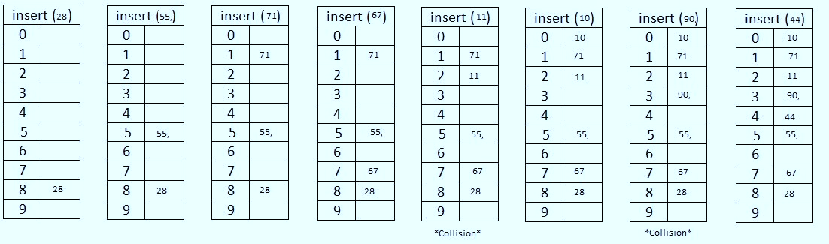 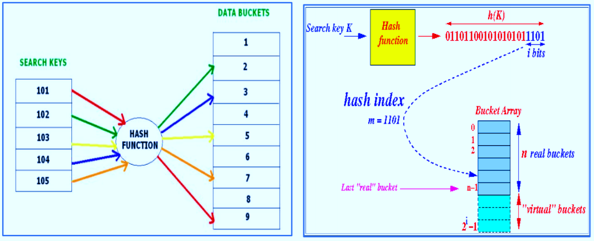

**Drawbacks:**

* Linear probing needs sequentially searching for the next empty cell in the table. But it may take a

long time, especially when most keys are in a contiguous region of the table

* The main problem is of clustering. Many consecutive elements form groups. Then, it takes time to search an element or to find an empty bucket.

|  |  |  |
| --- | --- | --- |
| **Roll no** | **Name** | **Seat no** |
| 226 | Sakshi Jagtap | S204148 |
| 227 | Shruti Dhumne | S204156 |
| 228 | Mayuri More | S204154 |
| 230 | Rushikesh Jadhav | S204149 |